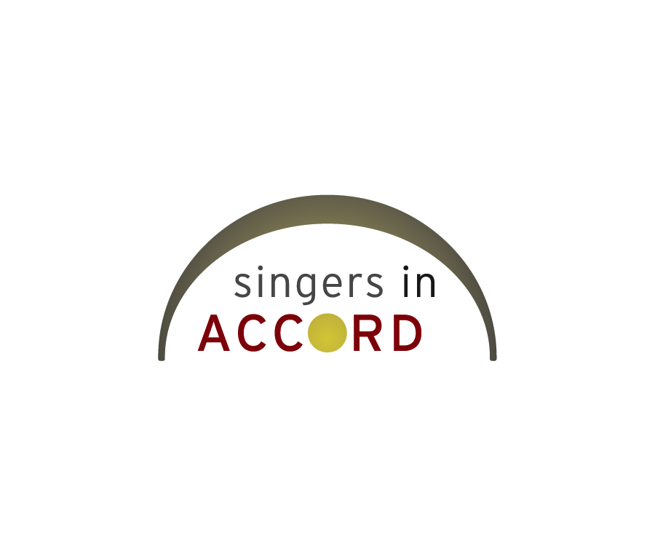

Linda Burk
7927 242nd Avenue N.E.
Stacy, MN 55079

Dear Linda,

Thank you for your continued support of Singers in Accord. Your contribution of $80.00 on October 25, 2011 was greatly appreciated. Donations like yours allow us to collaborate with high-quality musicians and conductors bringing unique musical experiences to our community. We are well into our 2011/2012 season and have an exciting concert, Conflict & Contentment, this weekend with Dr. David Mennicke. A performance with JD Steele comes in February, benefitting Partnership Resources, Inc., which provides services to adults with developmental disabilities. In May we will collaborate with Nancy Grundahl in a celebration of Earth Day and Minnesota composers. We promise to bring a different high-quality experience to your ears every time you hear us!

We also have exciting news about a donation match – our leadership team has committed $5000 in dollar-for-dollar matching funds to our giving campaign from now through November 25th. Making your donation online on November 16th, Minnesota's Give to the Max Day, also gives us the chance to win additional money in random drawings. Please consider sustaining our small arts organization by continuing your financial support during this match. You can donate directly to our GiveMN.org site at http://givemn.org/story/singers-in-accord .

We hope to see you at one of our concerts this weekend! Details about concert venues and times can be found on our website singersinaccord.org .

Sing out with your heart --
Sheri Williams

Sheri Williams, Fundraising Coordinator
Singers in Accord
Sheri.Williams@SingersInAccord.org
612-597-5483

* If you know of anyone interested in trying out for our choir, please direct them to our website www.SingersInAccord.org for more details.

